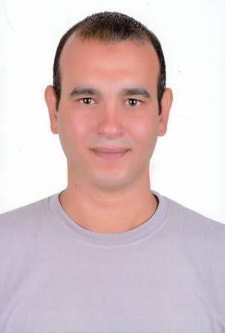
Mohamed Adel Ali Mohamed
Mustafa El Wakeel St, El Kuwait neighborhood,
Suez, Egypt.
+2062-331-48-13
+2011-455-20-881 & +2010-074-91-325
aswaany@gmail.com
PERSONAL INFORMATION
Date of Birth: | August 16th, 1981.
Marital Status: | Married.
Nationality: | Egyptian.
Military Service: | Final Exemption.
Driving license: | Valid till 05/02/2022.
OBJECTIVE
Seeking for challenging career in your company in any department where my abilities and skills can be developed and my knowledge can be applied.
EDUCATION
- High school business - General Division
- Graduation: 2000
WORK EXPERIENCE
- Works as accountant at Financial Group Office In Canada From 2000 - 2002
- Works as financial Reviewer at Ministry of Education From 2002 - 2004
- Works as trainer at Technological Development Center for (ICDL – MOS2010 – Photoshop – IC3 – Web Design) From 2002 - until now
- work as a trainer at technological development center at Army Institute for (ICDL – MOS2010 – Photoshop – Web Design) 2011 – 2014
- Working in Rental cars OFFICE (accountant - customer service )2014 – 2015
CERTIFICATIONS
- ICDL Certificate.
- Master M.O.S.2010 Certificate.
- Certified Trainer from Microsoft Corporation
- Microsoft Technology Associate (MTA) Certification
- Cambridge Certificate.
- IC3 GS4 Certificate.
- TOT Certificate.
SKILLS
1. Language skills
Arabic: | Native.
English: | Good.
French: | Basics.
Spanish: | Basics.
2. Computer skills
- Microsoft office package and Internet.
- Excellent knowledge Adobe (Photoshop, InDesign, illustrator)
- Data entry – Oracle – SQL.
- Experience in the computer Science & Software over 15y.
- Experience in Web Design over 10 years (HTML5 - PHP).
- Experience in working with databases.
3. Web Design Skills
- Experience in Web Design over 10 years (HTML5 - PHP).
- Experience in wordpress Design.
4. Soft skills
- Work as a volunteer or as a member in different societies.
- Interactive and fast enough to learn new technologies and sciences.
- Able to work in the desert or at sea in all various circumstances.
- Work under pressure
- Working with team spirits
INTERESTS
- Reading, Internet, Playing Chess.
REFERENCES
- I am happy to supply this on request.
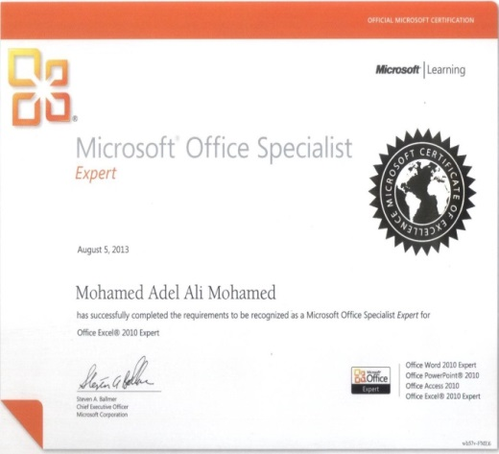  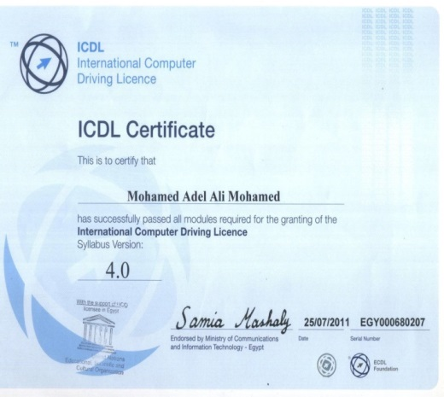 | 